Eileen Maroney | Results Screen shots | VBA Homework | August 19, 2019

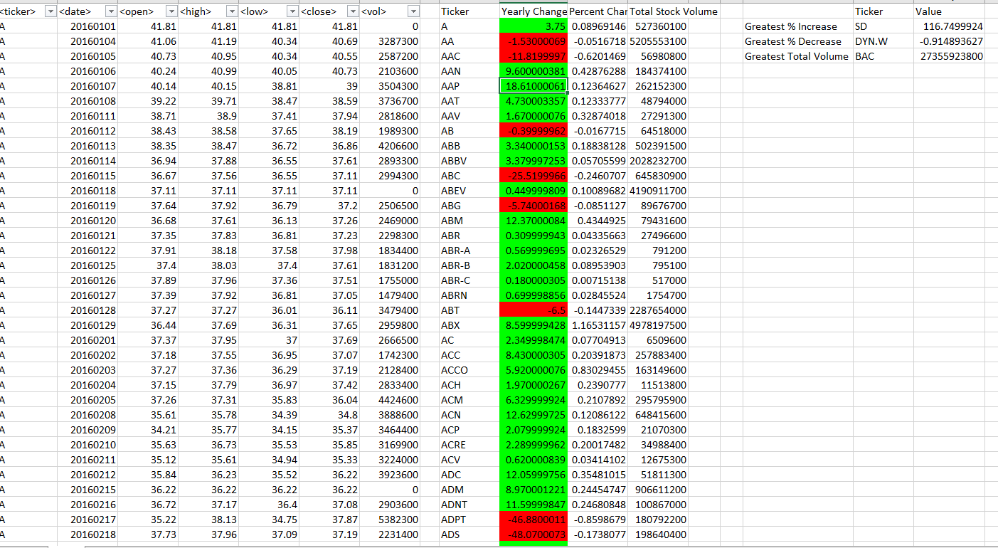

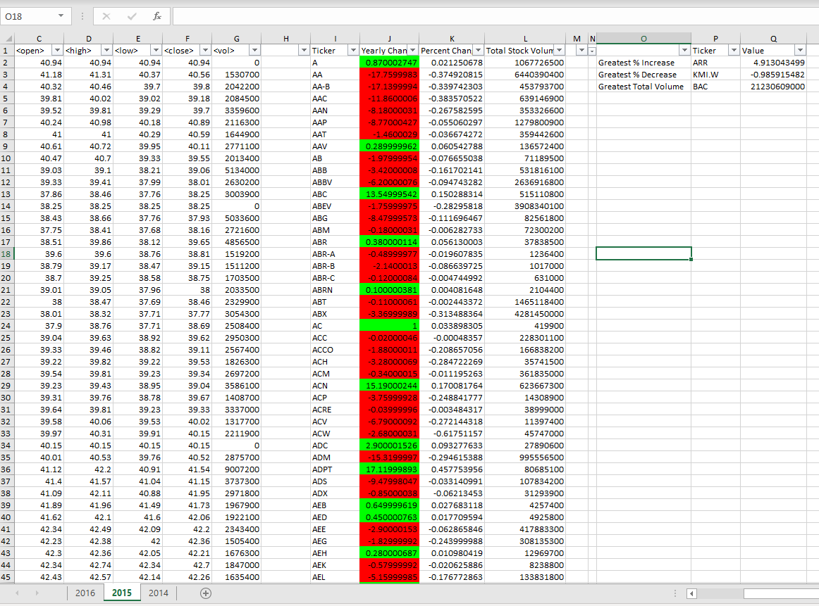

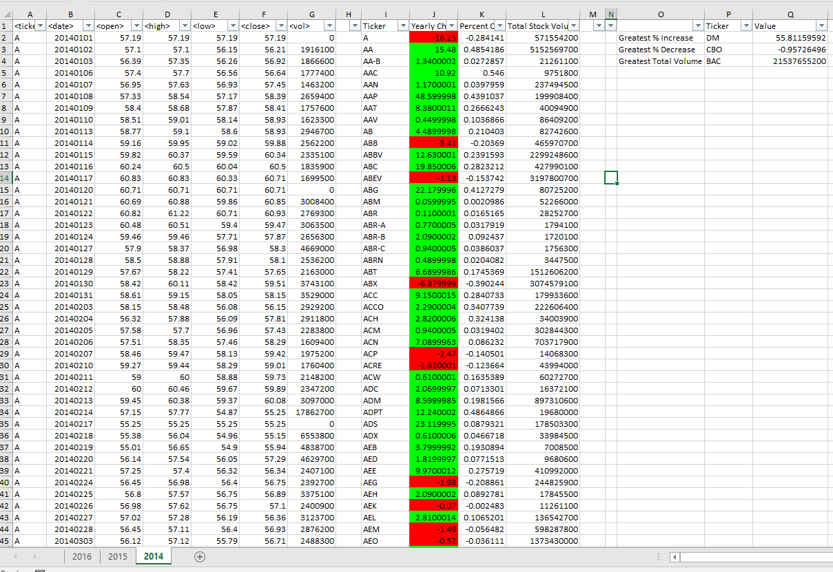

Sub StockTracker():

Dim Stock As String

Dim StockVol As Double

StockVol = 0

Dim Summary_Table_Row As Integer

Summary_Table_Row = 2

Dim lrow As Long

Dim ychange As Single

Dim stockopen As Single

Dim stockclose As Single

stockopen = Cells(2, 3).Value

Dim Percentchange As Single

Dim Lrowsummary As Long

Dim MaxPC As Single

Dim MaxV As Double

Dim MinPC As Double

MaxPC = 0

MaxV = 0

MinPC = 0

Dim TickerMaxPC As String

Dim TickerMaxV As String

Dim TickerMinPC As String

'Add Summary Table Headers

Range("I1") = "Ticker"

Range("J1") = "Yearly Change"

Range("K1") = "Percent Change"

Range("L1") = "Total Stock Volume"

'find the last Row

lrow = Cells(Rows.Count, 1).End(xlUp).Row

For i = 2 To lrow

'See if Stock symbol changes

If Cells(i + 1, 1).Value <> Cells(i, 1).Value Then

'Get Stock name

Stock = Cells(i, 1).Value

' Add volume total to the Summary Table

StockVol = StockVol + Cells(i, 12).Value

' Print the Stock name in the Summary Table

Range("I" & Summary_Table_Row).Value = Stock

' Print the Stock volume to the Summary Table

Range("L" & Summary_Table_Row).Value = StockVol

'

'Get the closing price

stockclose = Cells(i, 6).Value

'Calculate the ychange

ychange = stockclose - stockopen

'Calculate percentchange

If stockopen = 0 Then

Percentchange = 0

Else

Percentchange = ychange / stockopen

End If

'Print ychange in table

Range("J" & Summary_Table_Row).Value = ychange

'Print percentchange in table

Range("K" & Summary_Table_Row).Value = Percentchange

'Add one to the summary table row

Summary_Table_Row = Summary_Table_Row + 1

' Reset the Stock Volume Total

StockVol = 0

'Reset stockopen

stockopen = Cells(i + 1, 3).Value

' When cell has the same stock ticker

Else

' Add to the Stock Volume Total

StockVol = StockVol + Cells(i, 7).Value

End If

Next i

'Find last row of summary table

Lrowsummary = Cells(Rows.Count, 10).End(xlUp).Row

For i = 2 To Lrowsummary

'Format cell color in Percent change column

If Cells(i, 10) >= 0 Then

Cells(i, 10).Interior.ColorIndex = 4

Else

Cells(i, 10).Interior.ColorIndex = 3

End If

Next i

'Create Summary Table for Hard Exercise

Range("O2") = "Greatest % Increase"

Range("O3") = "Greatest % Decrease"

Range("O4") = "Greatest Total Volume"

Range("P1") = "Ticker"

Range("Q1") = "Value"

For i = 2 To Lrowsummary

'Get Max percent change

If Cells(i, 11).Value > MaxPC Then

MaxPC = Cells(i, 11).Value

TickerMaxPC = Cells(i, 9).Value

End If

'Get Min percent change

If Cells(i, 11).Value < MinPC Then

MinPC = Cells(i, 11).Value

TickerMinPC = Cells(i, 9).Value

End If

'Get Max Volume

If Cells(i, 12).Value > MaxV Then

MaxV = Cells(i, 12).Value

TickerMaxV = Cells(i, 9).Value

End If

Next i

'Print to Max/Min Summary Table

Range("P2") = TickerMaxPC

Range("Q2") = MaxPC

Range("P3") = TickerMinPC

Range("Q3") = MinPC

Range("P4") = TickerMaxV

Range("Q4") = MaxV

End Sub